|  |  |  |  |  |  |  |  |  |
| --- | --- | --- | --- | --- | --- | --- | --- | --- |
| Bước | 1 | 2 | 3 | 4 | 5 | 6 | 7 | Công việc |
| Khởi tạo | d[1]=0 | d[2]=2 | d[3]=1 | d[4]=2 | d[5]=3 | d[6]=2 | d[7]=2 | Tính d[u], S[0]={1} |
| 0 |  | d[2]=1 | d[3]=0 |  |  |  |  | S[1]={3}, Rank[1]=0 |
| 1 |  | d[2]=0 |  |  | d[5]=2 | d[6]=1 |  | S[2]={2},  Rank[3]=1 |
| 2 |  |  |  | d[4]=1 | d[5]=1 | d[6]=0 |  | S[3]={6},  Rank[2]=2 |
| 3 |  |  |  | d[4]=0 | d[5]=0 |  |  | S[4]={4,5},  Rank[6]=3 |
| 4 |  |  |  |  |  |  | d[7]=1  d[7]=0 | S[5]={7},  Rank[4]=4,  Rank[5]=4 |
| 5 |  |  |  |  |  |  |  | S[6]={}, rank[7]=5 |
| 6 |  |  |  |  |  |  |  | Dừng vì S[6]={} |

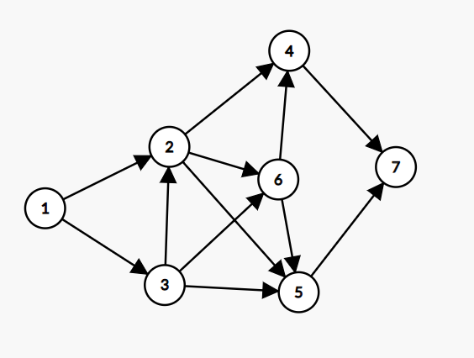

|  |  |  |  |  |  |  |  |  |  |  |  |
| --- | --- | --- | --- | --- | --- | --- | --- | --- | --- | --- | --- |
| Bước | A | B | C | D | E | F | G | H | J | K | Công việc |
| Khởi tạo | d[A]=0 | d[B]=1 | d[C]=1 | d[D]=1 | d[E]=2 | d[F]=2 | d[G]=2 | d[H]=1 | d[J]=1 | d[K]=3 | Tính d[u],  S[0]={A} |
| K=0 |  | d[B]=0 |  | d[D]=0 |  |  |  |  |  |  | Rank[A]=0,  S[1]={B,D} |
| K=1 |  |  | d[C]=0 |  | d[E]=1 | d[F]=1 | d[G]=1 |  |  |  | Rank[B]=1,  Rank[D]=1  S[2]={C,E,F,G} |
| K=2 |  |  |  |  | d[E]=0 | d[F]=0 | d[G]=0 |  |  |  | Rank[C]=2,  S[3]={E,F,G} |
| K=3 |  |  |  |  |  |  |  | d[H]=0 |  | d[K]=2  d[K]=1 | Rank[E]=3,  Rank[F]=3,  Rank[G]=3,  S[4]={H, K} |
| K=4 |  |  |  |  |  |  |  |  | d[J]=0 |  | Rank[H]=4  S[5]={J} |
| K=5 |  |  |  |  |  |  |  |  |  |  | Rank[J]=5  S[6]={K} |
| K=6 |  |  |  |  |  |  |  |  |  |  | Rank[K]=6  S[7]={} |
| K=7 |  |  |  |  |  |  |  |  |  |  | Dừng vì S[7]={} |

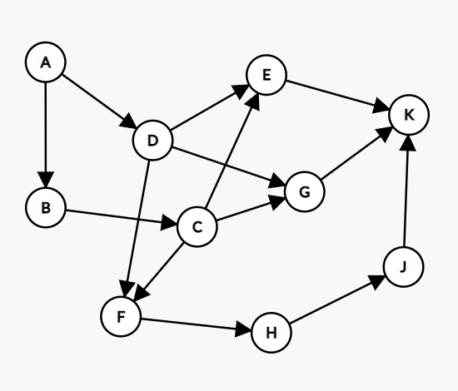

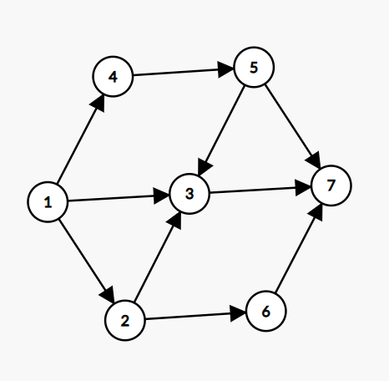

|  |  |  |  |  |  |  |  |  |
| --- | --- | --- | --- | --- | --- | --- | --- | --- |
| Bước | 1 | 2 | 3 | 4 | 5 | 6 | 7 | Công việc |
| Khởi tạo | d[1]=0 | d[2]=1 | d[3]=3 | d[4]=1 | d[5]=1 | d[6]=1 | d[7]=3 | Tính d[u], S[0]={1} |
| 0 |  | d[2]=0 | d[3]=2 | d[4]=0 |  |  |  | Rank[1]=0,  S[1]={2,3,4} |
| 1 |  |  | d[3]=1 |  | d[5]=0 | d[6]=0 |  | Rank[2]=1,  Rank[4]=1,  S[2]={3,5,6} |
| 2 |  |  | d[3]=0 |  |  |  | d[7]=2  d[7]=1 | Rank[5]=2,  Rank[6]=2,  S[3]={3,7} |
| 3 |  |  |  |  |  |  | d[7]=0 | Rank[3]=3,  S[4]={7} |
| 4 |  |  |  |  |  |  |  | Rank[7]=4,  S[5]={} |
| 5 |  |  |  |  |  |  |  | Dừng vì S[5]={} |